Step 1: Make sure you are in the your Region

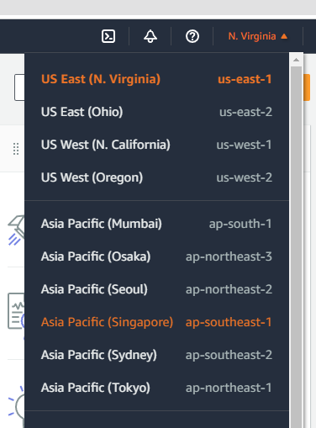

Step 2: Search for “EC2” service

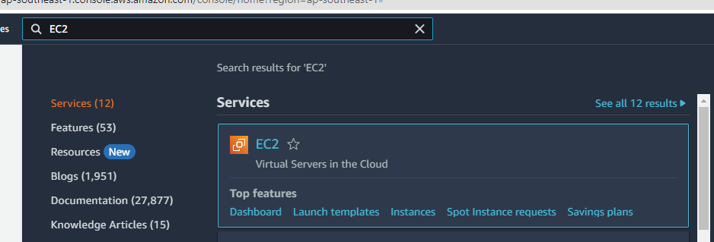

Step 3: Create two Security Groups one for Web and another for Database

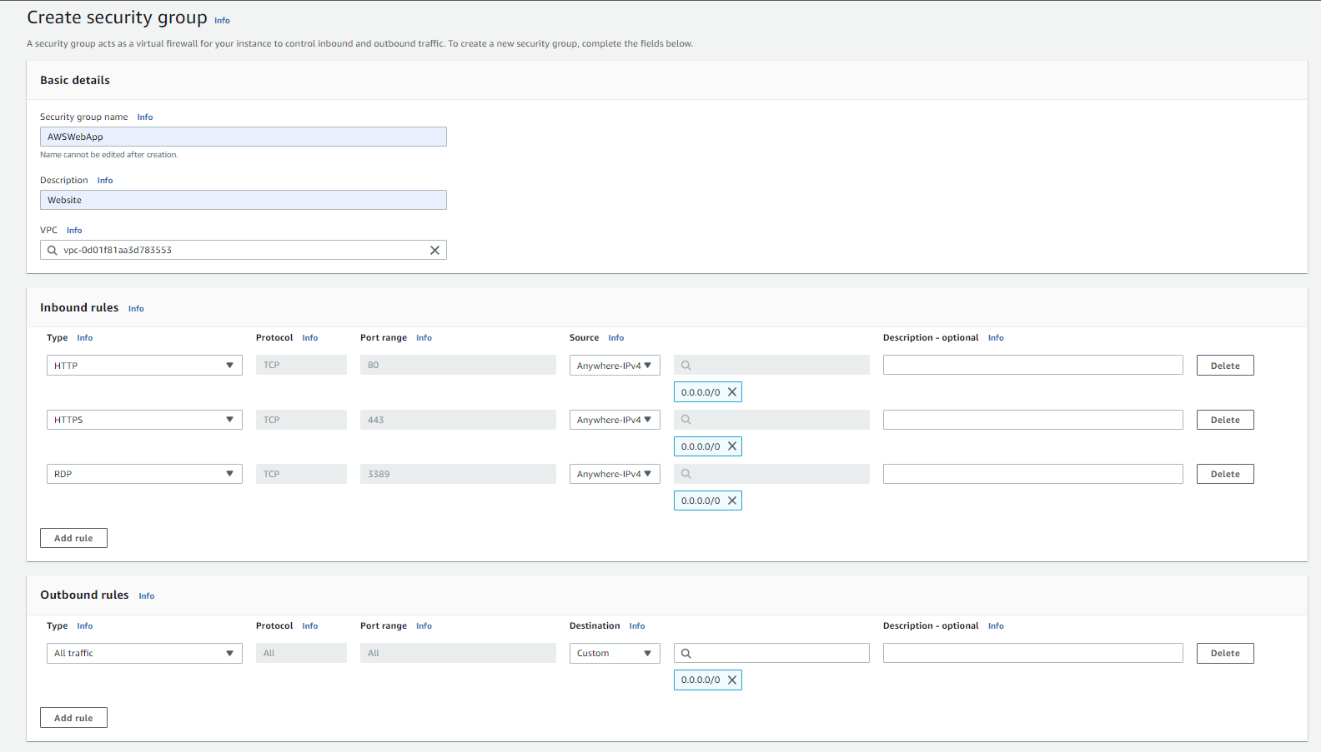 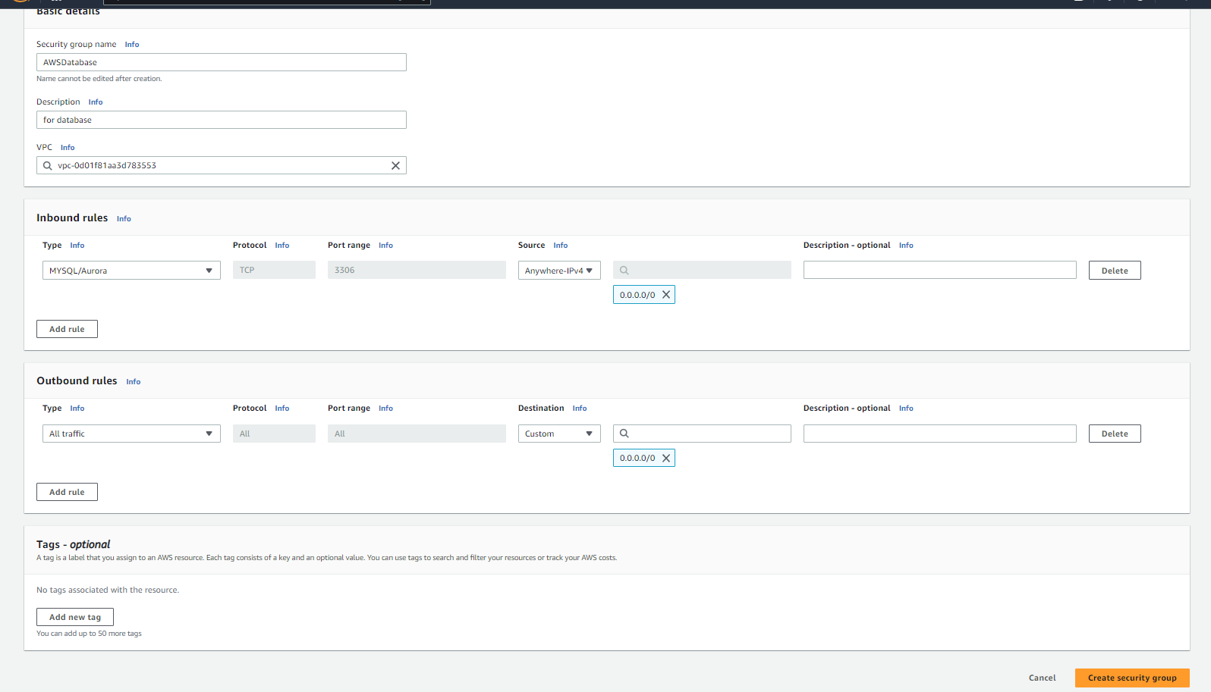

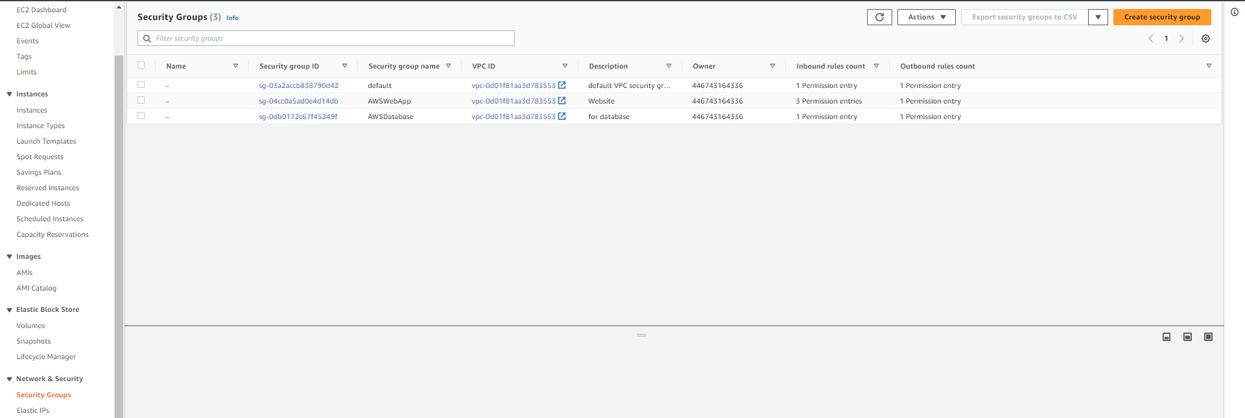

Step 4: Launch a new instance name as MyWebApp

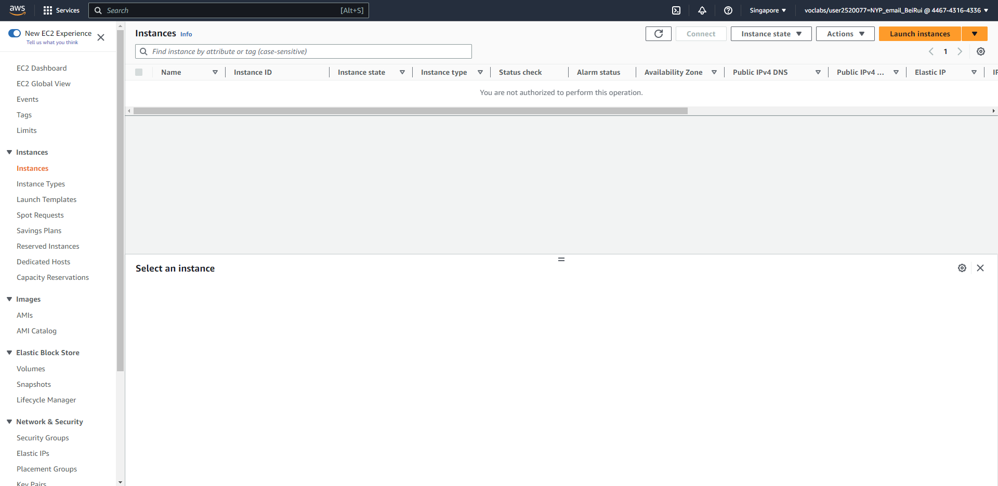

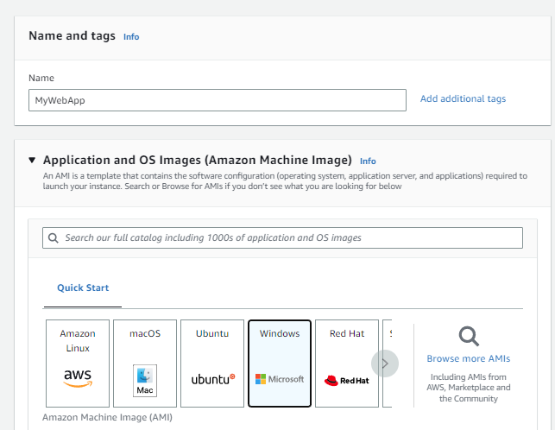

Step 5: Create a new key Pair and name it as SecureWebApp

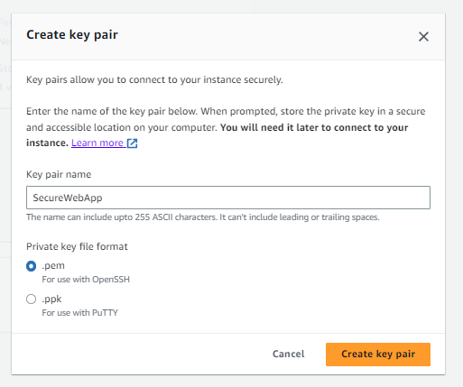

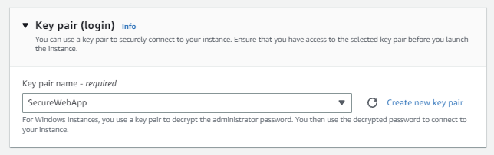

Step 6: put an existing security group

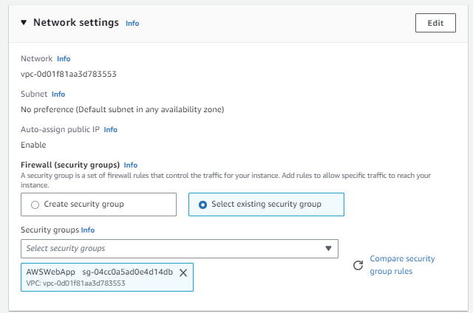

Step 8: search “RDS” service and create a database

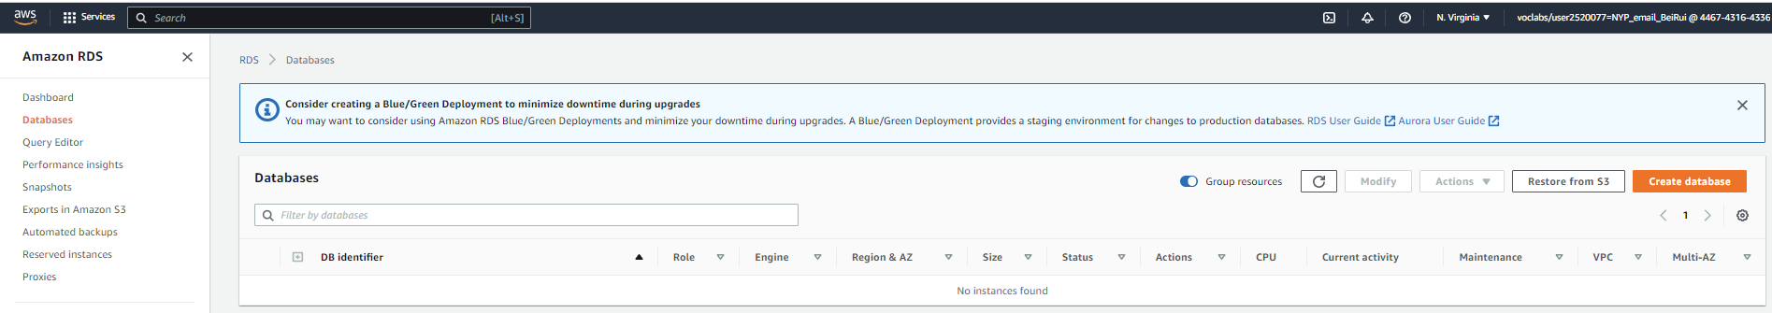

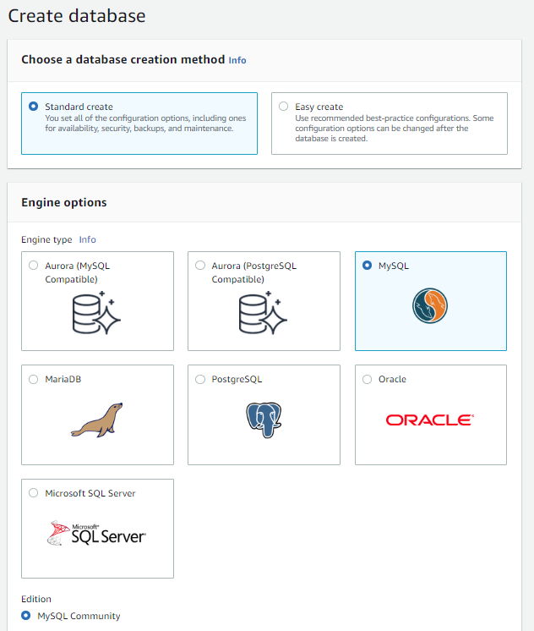 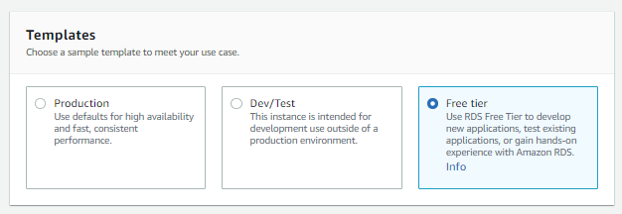

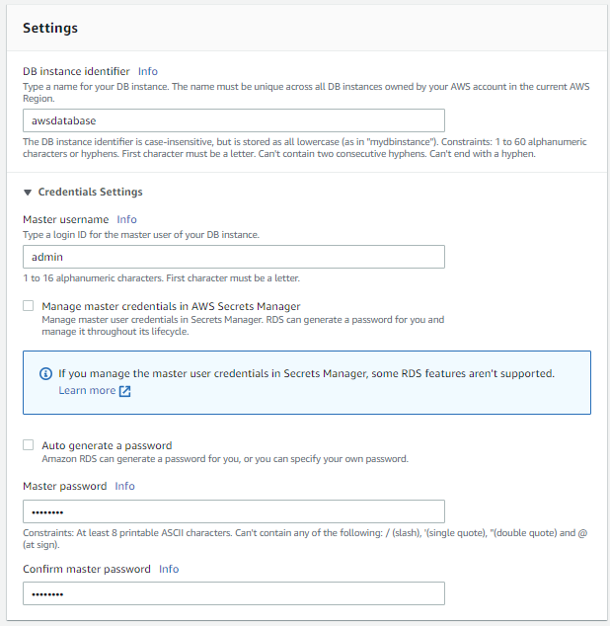 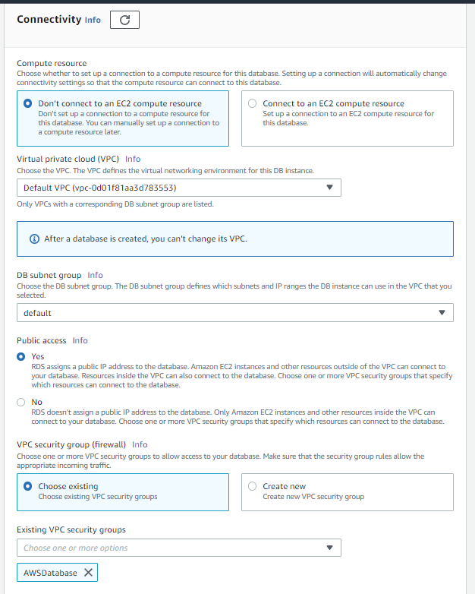 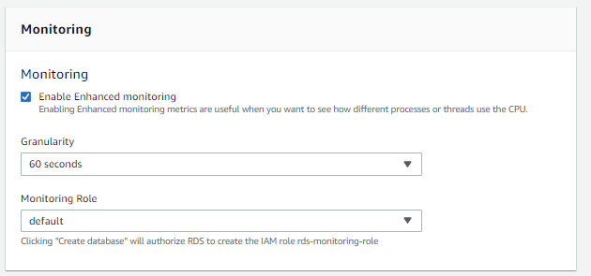

Step 9: to test connection, copy the endpoint and paste int MySQL

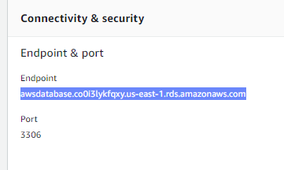

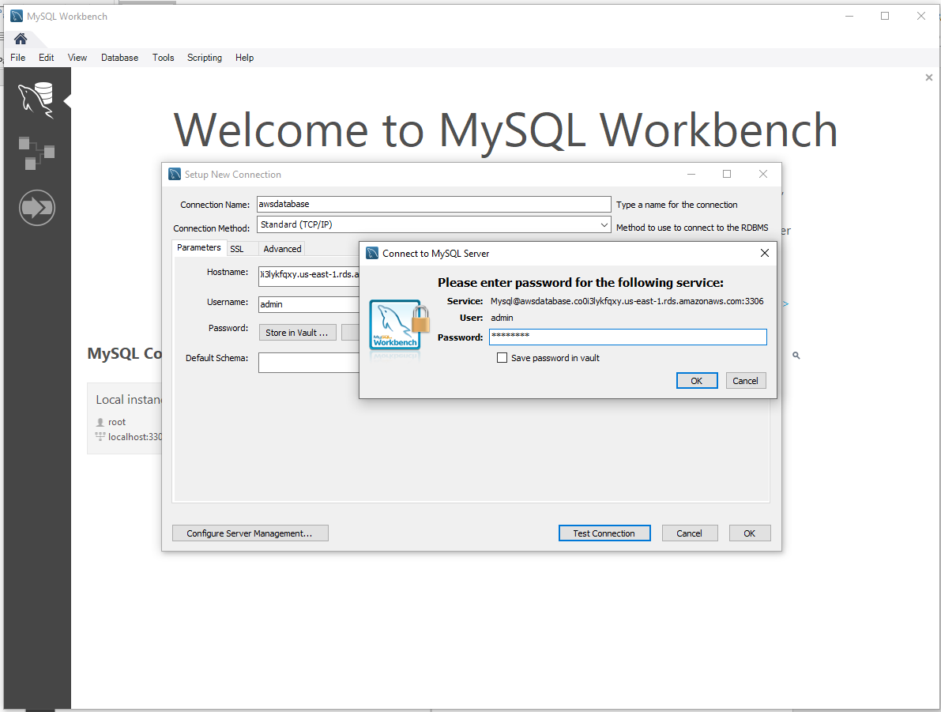 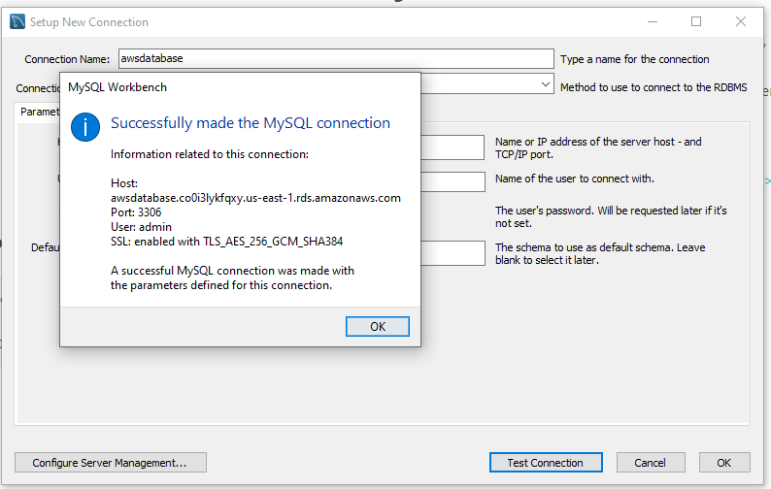

Step 10: open sql script

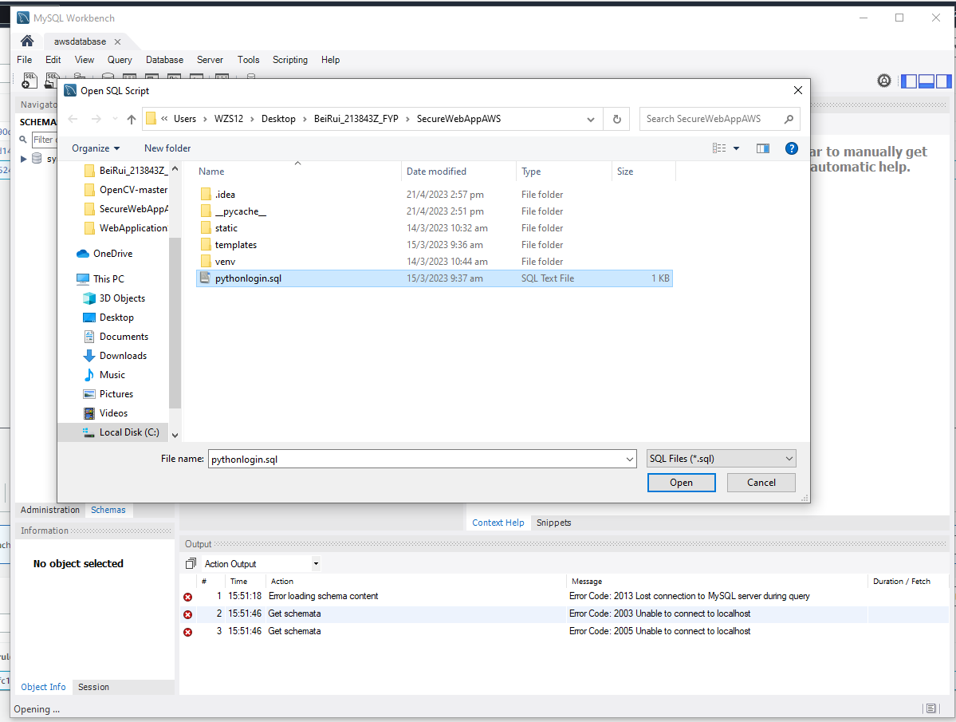

Step 11: create a linux database instance name it MyDatabase

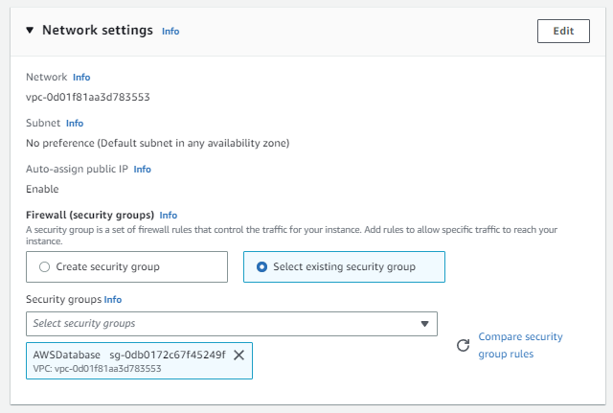 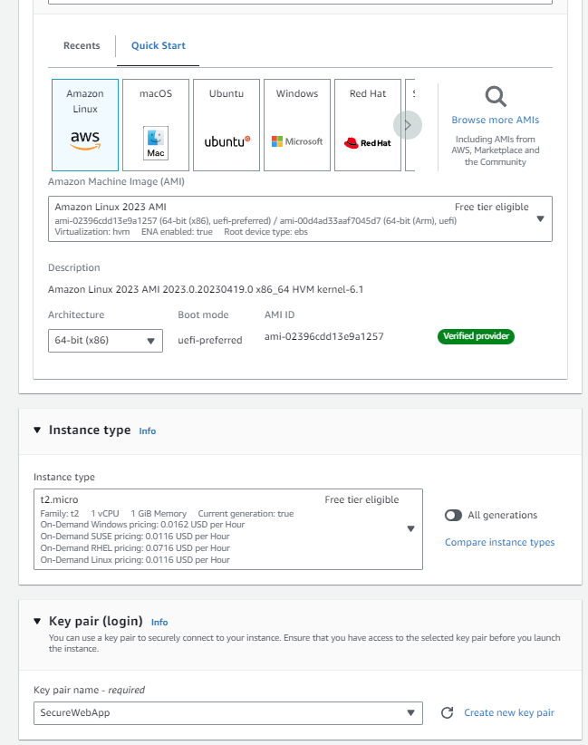

Step 12: select “MyWebApp” instance and connect using RDP client and get password

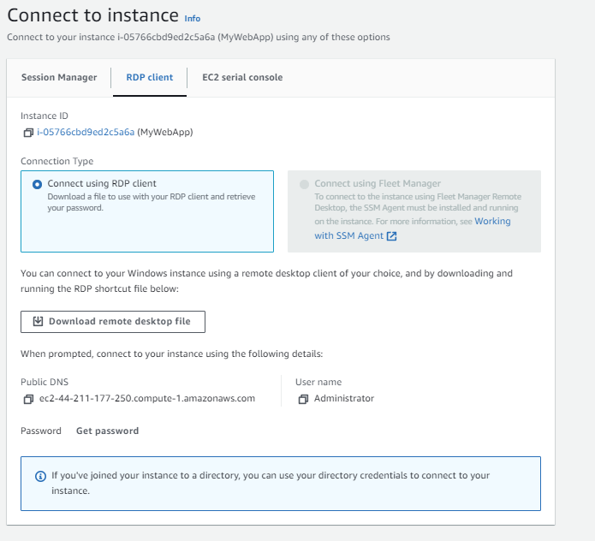

Step 13: upload key.pem

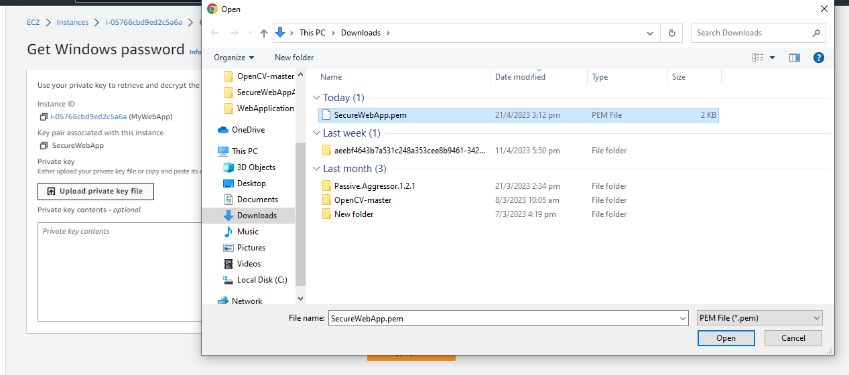

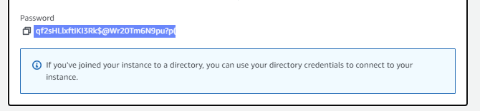

Step 14: connect rdp with password

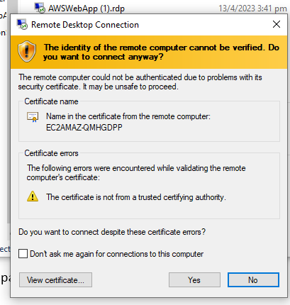

Step 15: change the firewall in the rdc to

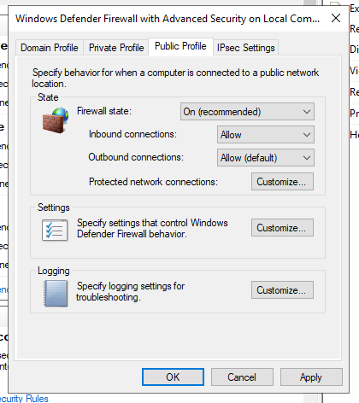

Step 16: in the remote desktop download the necessities.

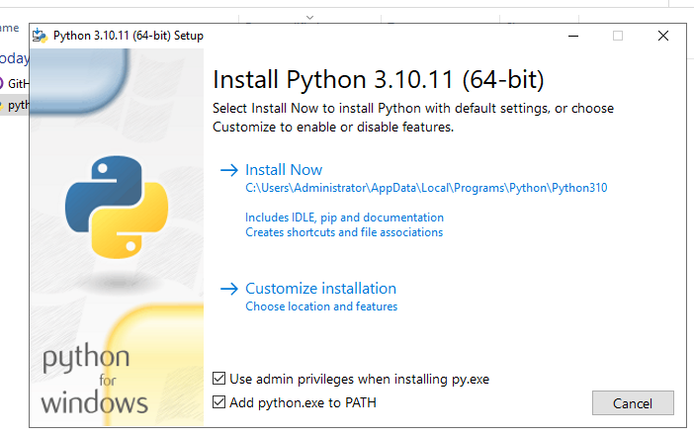 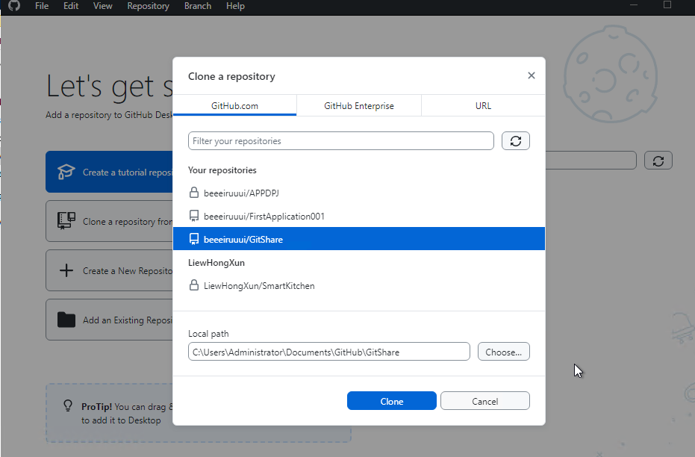

Step 17: open command prompt and

cd C:\Users\Administrator\Documents\GitHub\GitShare

pip install --upgrade pip

pip install --upgrade wheel

pip install -r requirements.txt

Every error just install separately: Pip install [name of package]

py app.py

Step 18: after installed, to open it to public, you will need to add elastic ip into the instance

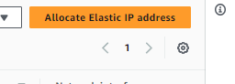in ec2

Step 19: and associate with mywebapp

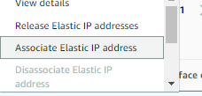

After every edit to the ec2 instance, you will have to reboot it again